


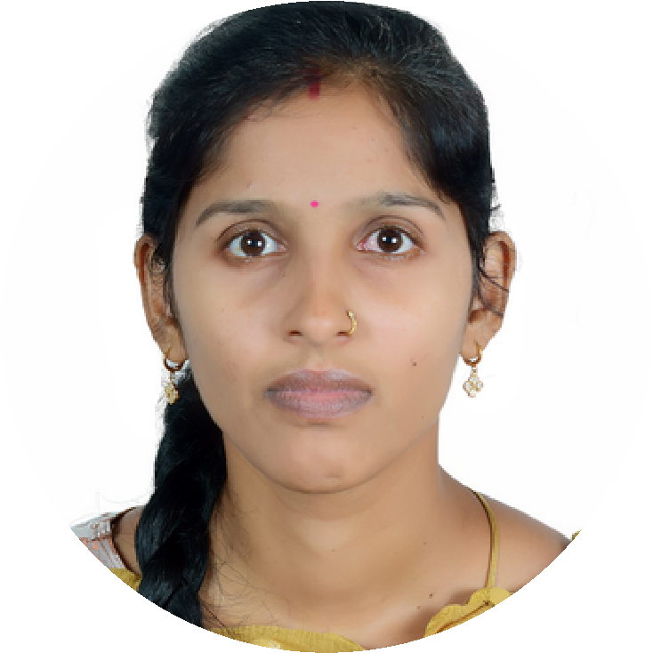

P.SUMANJALI
+971566346779
sumanjali0667@gmail.com
Karama ,

Dubai
MY SKILLS

DDDDD

- Updating of mails sending and receiving

Bhashyam developers in hyderabad
;
- Formulation process

- Knowledge of medicine and drugs
- Windows
- M.S Office

- Tally 9.0
- Profit maker
EEEEEOPEEEEEESSSD

WORKING WITH PASSION
TYPING CENTRE
Work as a Kanz Al Karama Documents Clearing Pro Services –Karama Dubai March -2023 to continue

March - 2023

RECIPTIONIST

:

PERSONAL DETAILS

- Nationality : India
- Date of Birth : 02/03/1995
- Passport Number : W1544231
- Expiry Date : 06/06/2032
- Visa Status : Own visa

- OCT 2017 – MARCH 2020

Multi tech medical system 2017-2022

- Handling the client’s both face to face and by calls.
- Maintain the service level and make sure the customer satisfaction is on high priority
- Good customer handling ability and quick understanding client needs
- Always achieved the punctuality and topper position for customer satisfaction

LANGUAGES KNOWN
- ENGLISH
- HINDI
- TELUGU

EDUCATIONAL QUALIFICATION
DEGREE (B.Z.C) Discontinue
Osmania university, India -2016
Board Of Intermediate Education
- Govt jr college, India -2012
Board Of Secondary Education
- A.H.S (G) High School India-20

